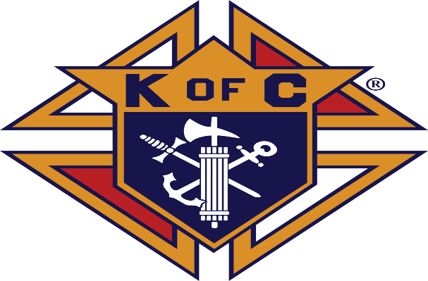

Knights of Columbus
Council 1570
$250 Scholarship

For a graduating Waukon High School student of the catholic faith.
Please submit a 500 word essay on one of the following topics:
Charity
Patriotism
Unity
Catholic Faith

Must be submitted by January 31.
Submit your essay to the Guidance Office
Or email directly to
rbenzing.benzingsurveying@gmail.com

